**Name: Session:**

**Programming II**

**Working with Menus**

**Lab Exercise 4.15.2020**

1. Design an application that works as a shopping cart system. The user should be able to add any of the following items to his or her shopping cart:

Print Books (books on paper)

I Did It Your Way $11.95

The History of Tuva $14.50

Learn Calculus in One Day $29.95

Feel The Stress $18.50

Spelin Made Esy $0.45

Audio Books (books on tape)

Learn Calculus in One Day $24.95

The History of Tuva $11.95

The Science of Body Language $12.95

Relaxation Techniques $11.95

The applications main form should appear similar to the one below:

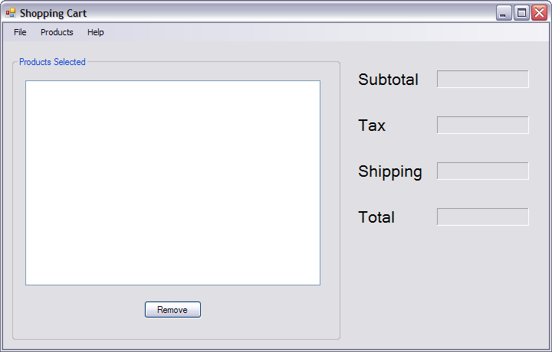

The list box shows all items in the shopping cart. There is a 6% sales tax on the total cost of the items in the shopping cart. Also, for each item in the shopping cart, there is a $2.00 shipping charge. To remove an item from the shopping cart, the user selects the item in the list box and clicks the Remove button. The subtotal, tax, shipping and total fields should be adjusted accordingly.

The main form’s menu system should be as such:

Products

Help

File

About

Print Books

Reset

Audio Books

Exit

When the user selects the Reset from the File menu, all items in the shopping cart should be removed, and the subtotal, tax, shipping, and total fields are cleared. When the user selects Exit from the File menu, the application ends. When the user selects About from the Help menu, a simple About box should appear. When the user selects Print Books from the Products menu, a Print Books form should appear.

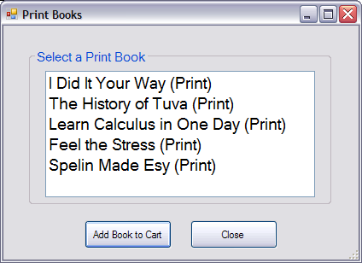

To add one of the items in the list to the shopping cart, the user selects it and clicks the Add Book to Cart button. To cancel the operation the user clicks the Close button without selecting a book.

To add one of the items in the list to the shopping cart, the user selects it and clicks the Add Book to Cart button. To cancel the operation the user clicks the Close button without selecting a book.

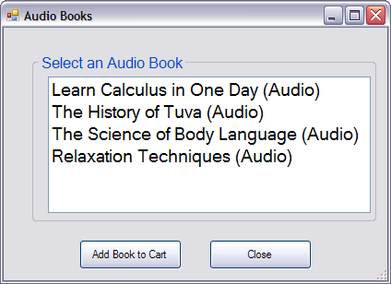

1. Start working on the code for frmMain.
2. Create the following global public static variables that are shared between forms.

public static double subTotal;

public static int numItems;

public static string item;

public static double cost;

1. Add the following code to the btnRemove_Click event handler.

double shipping, tax, total, takeAway;

int index = lstProducts.SelectedIndex;

takeAway = (double)lstCost.Items[index];

lstProducts.Items.Remove(lstProducts.SelectedItem);

lstCost.Items.Remove(lstCost.Items[index]);

numItems -= 1;

subTotal -= takeAway;

shipping = 2 * numItems;

tax = 0.06 * subTotal;

total = subTotal + tax + shipping;

lblSubtotal.Text = subTotal.ToString("c");

lblShipping.Text = shipping.ToString("c");

lblTax.Text = tax.ToString("c");

lblTotal.Text = total.ToString("c");

1. Add the following code to the ResetToolStripMenuItem_Click event handler.

lstProducts.Items.Clear();

lblShipping.Text = "";

lblSubtotal.Text = "";

lblTax.Text = "";

lblTotal.Text = "";

1. Add the following code to the PrintBooksToolStripMenuItem_Click event handler.

frmPrint print = new frmPrint();

double shipping, tax, total;

print.ShowDialog();

lstProducts.Items.Add(item);

lstCost.Items.Add(cost);

shipping = 2 * numItems;

tax = 0.06 * subTotal;

total = subTotal + tax + shipping;

lblSubtotal.Text = subTotal.ToString("c");

lblShipping.Text = shipping.ToString("c");

lblTax.Text = tax.ToString("c");

lblTotal.Text = total.ToString("c");

1. Add the following code to the AudioBooksToolStripMenuItem_Click event handler.

frmAudio audio = new frmAudio();

double shipping, tax, total;

audio.ShowDialog();

lstProducts.Items.Add(item);

lstCost.Items.Add(cost);

shipping = 2 * numItems;

tax = 0.06 * subTotal;

total = subTotal + tax + shipping;

lblSubtotal.Text = subTotal.ToString("c");

lblShipping.Text = shipping.ToString("c");

lblTax.Text = tax.ToString("c");

lblTotal.Text = total.ToString("c");

1. Add the following code to the AboutToolStripMenuItem_Click event handler.

string message;

message = "SuperCart\n" + "Better Software\n" + "CopyLeft 2020";

MessageBox.Show(message);

1. Now we will work on the frmPrint code.
2. Add the following code to the btnAdd_Click event handler.

frmMain.item = lstPrint.SelectedItem.ToString();

frmMain.numItems += 1;

switch (lstPrint.SelectedIndex)

{

case 0:

frmMain.subTotal += 24.95;

frmMain.cost = 24.95;

break;

case 1:

frmMain.subTotal += 11.95;

frmMain.cost = 11.95;

break;

case 2:

frmMain.subTotal += 12.95;

frmMain.cost = 12.95;

break;

case 3:

frmMain.subTotal += 11.95;

frmMain.cost = 11.95;

break;

case 4:

frmMain.subTotal += 5.95;

frmMain.cost = 5.95;

break;

}

this.Close();

1. Now we will work on the frmAudio code.
2. Add the following code to the btnAdd_Click event handler for the frmAudio class.

frmMain.item = lstAudio.SelectedItem.ToString();

frmMain.numItems += 1;

switch (lstAudio.SelectedIndex)

{

case 0:

frmMain.subTotal += 24.95;

frmMain.cost = 24.95;

break;

case 1:

frmMain.subTotal += 11.95;

frmMain.cost = 11.95;

break;

case 2:

frmMain.subTotal += 12.95;

frmMain.cost = 12.95;

break;

case 3:

frmMain.subTotal += 11.95;

frmMain.cost = 11.95;

break;

}

this.Close();

1. Test your program. When the program is working, take a screen shot of all forms in the running state, paste into a word processing document, and turn in.